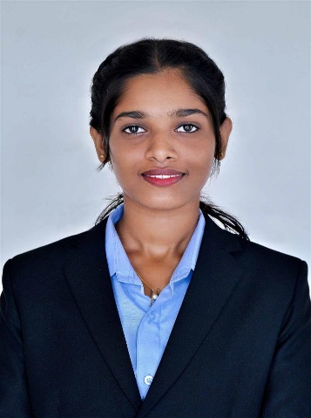
NISHMITHA N
Permanent Address: Nadumane house, P.O Ukkinadka,
Kasaragod District, Kerala, 671552
Mobile No: 9048719297
Email: nishpoojary97@gmail.com
LinkedIn:www.linkedin.com/in/nishpoojari
Github: https://github.com/nishpoojari

Career Objectives
I aim to work with an organization where I can develop new skills, enhance my abilities, and contribute to achieving the company's goals while advancing my own personal growth.

Education:

Qualification | Institution | Year | Mark in Percentage
Master of Computer Application | St Philomena college, Puttur | 2025-2027 | currently  pursuing
Bachelor of Computer  Application | St Philomena college, Puttur | 2022-2025 | 78%
PUC (PCMB) | Swamiji’s Higher Secondary  School, Edneer | 2020-2022 | 82%
SSLC | Shree Sathyanarayana High  School, Perla | 2019-2020 | 97.77%

Technical Skills and Ability:

Programming Languages: C, PHP, Java, Python (basics)
Web Technologies: HTML5, CSS, JavaScript (basics), Angular
Frameworks: Flask
Database: SQL, MySQL (basics)
Operating System: Windows
Microsoft Office Tools: MS Word, MS PowerPoint, MS Excel

Academic Projects:
Virtual Art Gallery (Mini Project)
Developed a web-based art gallery system with Artist and User modules. The platform allows artists to upload and manage artworks, while users can view, comment on, and add artworks to their wishlist. Technologies: HTML, CSS, JavaScript, MySQL and Java

Achievements/Participations:
Participated in Vision (Intracollegiate fest) at St Philomena College, 2023-24
Participated in Internal Smart India Hackathon at St Philomena College, 2024
Participated in NAIN 2.0 Project Competition at St Philomena College, 2024

Certifications:
- Cybersecurity & Digital Forensics Training Certificate By TALFOR
- NPTEL – Foundations of Cryptography (IIT Bangalore)
- WordPress Website Development Certification
- Certifications through Infosys Springboard:
- Programming using java, java 11 beyond basics, java language features and fundamentals
- Introduction to Artificial Intelligence, Cloud Computing, Cyber Security,
- introduction to Automation Testing
5. Time Management, Active Listening, Design Thinking Certification
6. Certification By MongoDB:
- Introduction to MongoDB

Languages Known: English, Hindi, Malayalam, Kannada, Tulu

Declaration
I hereby declare that all the above furnished details are true to the best of my knowledge. If given an opportunity, I assure you Sir / Madam, I will work to the best of your satisfaction and for the betterment of the organization.
Thanking You
Date: Yours Faithfully
Place: Kasaragod (Nishmitha N)

